**Overview**

Social, Technology, Economic and Political trends are creating a confluence that suggests new skills will be required to secure employment.

Smart-Creative people are in demand. It is a rising tide. Join in.

To be creative it is important to access your optimal creative state: FLOW

**Problem**

We have been educated in such a way that we lose creativity. It is compounded by the reliance on outdated ways of measuring performance at work.

We are taught “smarts” based on Bloom’s Taxonomy. Compare that to research for NASA carried out by George Land and Teresa Amablie show deterioration in creativity during formal education and early career.

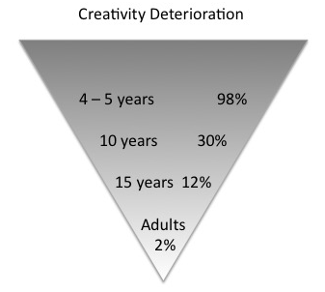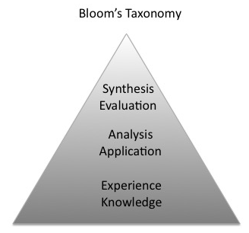

**Solution**

There is no point in getting into a blame game. We can reclaim our creativity for ourselves.

To achieve FLOW is worth considering how to best set your personal environment physically, socially, emotionally. The following model presents the basic dimensions

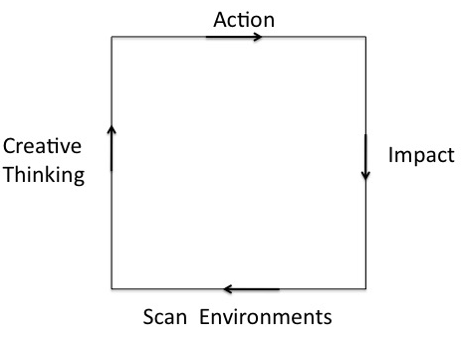

The four steps

1. Scan Environments to set the climate
2. Creative Thinking: new techniques & library
3. Action: Be resilient to deliver
4. Impact: Reflect and assess changes

To determine if this way of creating is right for you fill in the following questions.

**Environment & Safety: Who has put you down?**

Parents ⬜ Teachers ⬜ Bosses ⬜ Peers ⬜ Friends ⬜ Family ⬜

**Personal Biases**

Do you consider yourself to be Open-minded ⬜

**What stops you being creative?**

Fears ⬜ Friends ⬜ Inner Censor ⬜ Lack of Time ⬜

**Imaginative Thinking**

Would you like to learn creative thinking? ⬜

Do you currently use it: at work ⬜ for yourself ⬜ for others ⬜

**Delivery**

*Connection*

Who would you like to connect to (list 3 people) ___________, ___________, _________

*Strength*

Do you need to improve emotional resilience? ⬜

*Compassion*

What top 3 things are you compassionate about? ___________, ___________, _________

Value – the outcome of delivery

**Autonomy and actualsation**

Are you confident in your own judgement ⬜ Are others ⬜

Do you feel satisfied ⬜ Do you always achieve what you want ⬜

If you have mentally ticked any of the above boxes you may consider going to the second stage of the process. It is a ten day trial that is a series of thought-experiments that will acquaint you with the process.